**Writing: Section B**

**Write a story about: The Birthday Party.**

WRITE ABOUT WHAT YOU KNOW! IF YOU HAVE NEVER BEEN TO A JOB INTERVIEW, SHOULD YOU WRITE ABOUT IT? USE YOUR REAL-LIFE EXAMPLES!

This is not an exhaustive list but use this to help you plan.

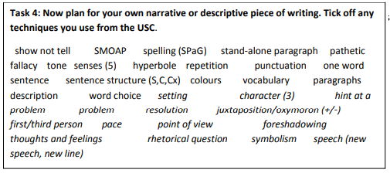

(ideas– A trampoline birthday party for you or an adult)

A surprise birthday party

A house/garden party

USE THE SPACE BELOW TO JOT DOWN YOUR IDEAS!

**The 2.0 Plan**

|  |  |  |
| --- | --- | --- |
| **Paragraphs** | **Content** | **Techniques** |
| Paragraph one | e.g. describe the atmosphere | e.g. use your senses and vocab |
| Paragraph two |  |  |
| Paragraph three | e.g. a dramatic section in your story | e.g. stand-alone paragraph |
| Paragraph four | Character reactions | e.g. simile or a metaphor, list of 3, vocab |
| Paragraph five |  |  |
| Paragraph six |  |  |

**Possible sentence starters:**

Being greeted by a curtain of gold, followed by drooping diamonds everywhere wasn’t something she had ever seen before. The mesmerising bling sure made a statement.

More and more people gathered into the compact room that now began to make her feel sick. The concoction of perfume, mixed with body odour wasn’t her idea of fun. Sienna could sense the unrest of the group and wondered why all these adults were here. Studying one face and then another and then another, she finally settled on the one who made eye contact with her and let out a bellowing cry...

OR

A wave of sudden excited washed over him as he heard the music in the distance. Each step left his heart pounding faster and faster...